August 2024 Z-Wave RF Range Testing

# Executive Summary

Coming once the testing is complete

# Goals

* ZRAD to ZRAD ZWLR RF range testing in various environments generating a Heat Map using Geographic Location Command Class and a GPS receiver
* ZRAD End Device Mounted on a Motorcycle to move around quickly
  + Some data may be captured using an eBike or walking especially in urban environments
* ZRAD Controller running Z-Wave JS to pull GPS locations and store in a .CSV file
* 2 videos – 1 ~3min short at WW, longer ~5 min YouTube
* Environments:
  + Wooded
    - [Bound](https://www.google.com/maps/place/BoundTree%2FLine+Hill+Parking/@43.2080352,-71.7716687,280) Tree ATV Henniker NH
    - Rockingham [trail](https://www.nhstateparks.org/find-parks-trails/recreational-rail-trails/rockingham-recreational-rail-trail,-fremont-branch) Freemont to Sandown
    - [Hopkington-Everet OHRV](https://www.google.com/maps/place/Hopkinton-Everett+OHRV+Trails+Area/@43.1239432,-71.6538497,1887) trails
  + Open agricultural field
    - Wagon Hill Durham NH (not quite big enough?)
  + Green houses?
  + Residential
    - Newton MA
    - Dover NH
  + Urban
    - Boston Silabs Office
      * Do the windows have metal tinting with poor RF?
      * Can we get on the roof? Probably not
      * Use the top floor of the NECCO parking deck?
    - Dover NH
      * Controller on top of the [Garrison Hill tower](https://www.google.com/maps/place/Garrison+Hill+Tower,+Abbey+Sawyer+Memorial+Hwy,+Dover,+NH+03820/@43.2094265,-70.8704013,333) which has line-of-sight to much of Dover below for several miles and plenty of urban streets
        + Too many trees – do not use
      * Can drive & park at the base of the tower
      * Trial on 8/10 did not go well. Too many trees surrounding the tower results in few if any pings even on the road just below the tower. Only time it connects is line-of-sight which is rare at ground level.
      * [Shaw Fields](https://www.google.com/maps/@43.1664761,-70.8689548,396m/data=!3m1!1e3!5m1!1e3?entry=ttu#:~:text=43.165965%2C%20%2D70.869717) is an open area surrounded by neighborhoods somewhat hilly but did yield good results
    - Strafford NH
      * The [Stratham Hill Tower](https://www.google.com/maps/place/Stratham+Hill+Tower/@43.0312354,-70.8911063,3178) is an alternative but doesn’t have as many streets nearby
      * Requires a hike up the hill to get to the tower
  + Water – need a boat – lakes or the ocean depending on the weather
* At some point:
* Use ZRAD to capture GPS, but also capture stats of other devices
  + Use Indicator Get? ZWInfo Get? Needs to be a secure GET to know frame made both directions clean
  + ZW mesh with ZRAD
  + Commercial products
    - Ring
    - Zooz light switch? Blink xmas lights all over the bike and night Electric Cowboy style!
      * Need a large battery and inverter – Jackery?
    - 3Labs flow meter
* Compare with Wifi, Zigbee, Matter, Lora, others?
  + 2.4 protocols in urban environments will probably suck due to all the noise
* Compare with YAGI antenna – point-to-point
* Example use-cases
  + Track skydiving jump (Homeseer)
  + Track model rocket launch
  + Track glacier movement for months at a time (need low-power)

# Journal

## 2024-08-12 – Shaw Fields Dover NH

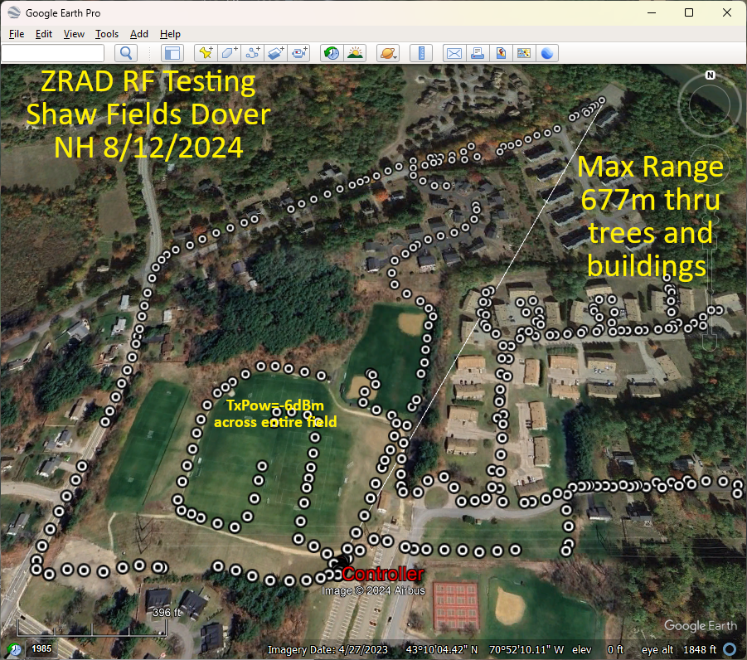The Shaw fields in Dover are open fields surrounded with neighborhood streets. The area is hilly but the fields are flat with the parking lot on a hill overlooking them. There is only about 300m of direct line of sight. Time didn’t allow capturing the entire area and I was walking but an eBike with a faster sample rate would be a better idea to get more data faster.

The fields yielded -6dBm TxPower levels at over 150m. The longest range is 677m but that includes numerous trees and wood frame condos in between. TxPower is +20 at that extreme.

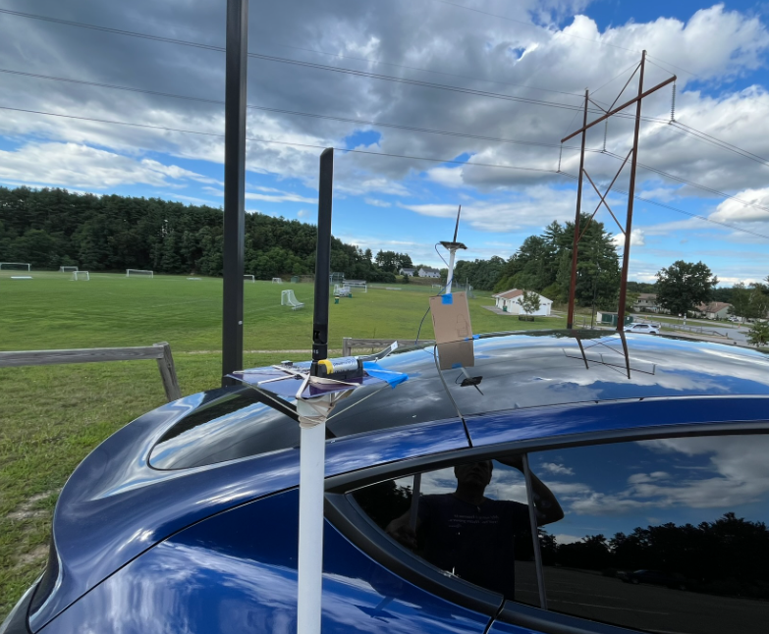The controller is mounted about 24” above a Tesla on a PVC pipe. Is the roof of the car providing additional ground plane effect to increase range? Will have to experiment with the controller standalone well away from any metal. If that is much shorter, then we’ll have to try with a cookie sheet or circular cardboard wrapped in aluminum foil! Maybe 4 or 8 rods at a 45 degree angle?

Google Earth Pro (download the desktop version) creates the image above via:

1. Edit the .csv to have only the data to be plotted
2. Open GEPro
3. File->Open
4. Select Generic Text (*.csv)
5. Pop-up will open to select the columns
6. Latitude and Longitude are usually detected automatically from the 1st row of the .csv
   1. If not, select them
7. Change the format from STRING to FLOATING POINT (this is the key)
8. Click on Finish
9. View-> check Sidebar
10. Scroll down to the imported file, click the check on and the points will be displayed
11. Use Add Path to add a path – the length is shown in the Length tab (change to meters)
12. In the sidebar, select the Controller data point, change its name and color
13. Screen shot then add more text to the image using Gimp

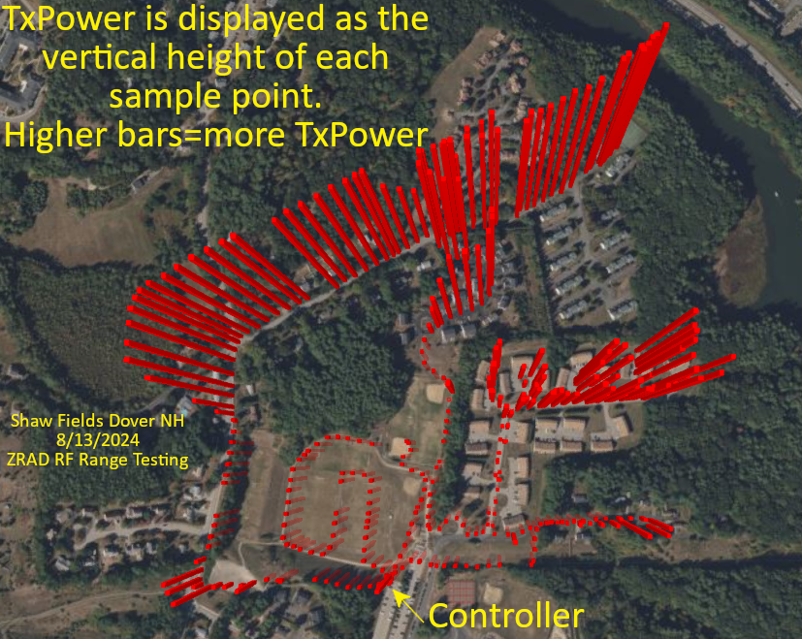This image is created using Excel 3D maps feature

1. Open the .csv in Excel
2. Save the file as .xlsx
3. Click on 3D Maps (if not in the toolbar, search for it)
4. The 3D maps app should open and automatically find the Latitude and Longitude
5. Zoom in on the location – the points are all mashed together as the dots are far too large
6. Layer Options
   1. Reduce size to 0
7. Click on Height and add TxPower – reduce the height to zero percent
8. Change the color as desired
9. Themes -> select one with a satellite view
10. Screenshot and add more text using Gimp
11. 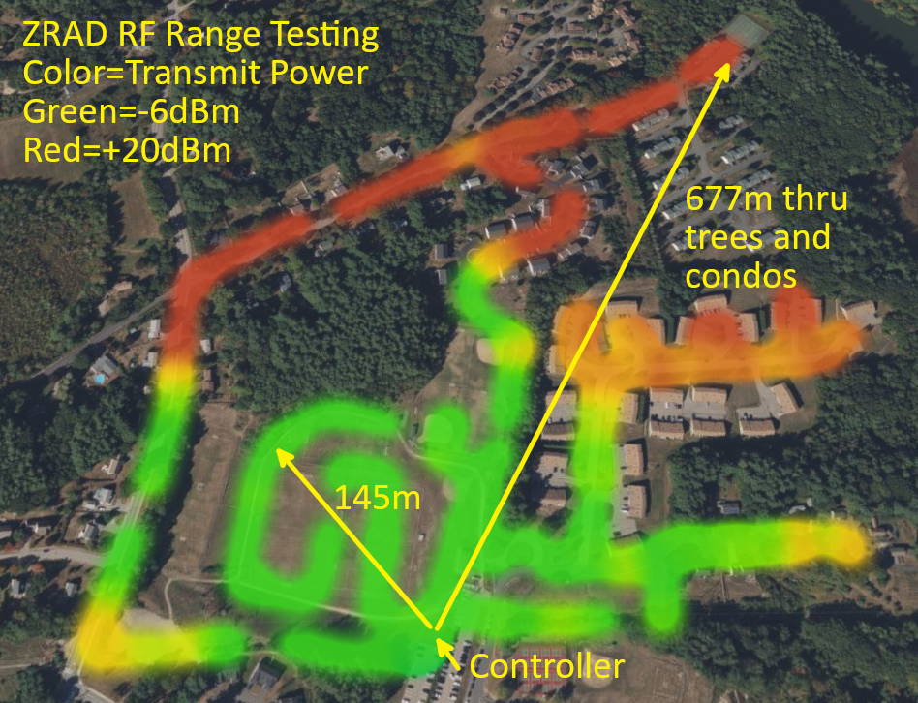To create a heatmap, click on the heatmap icon at the top of the Layer Pane
12. Change Visual Aggregation to Average
13. Adjust the radius of Influence and the color scale to the desired levels
14. Try other options
15. Screenshot and add text/arrows in Gimp

Raw data is in the file 202408ShawFields.csv checked into the ZRAD repo in the Test folder.

## 2024-08-10 – Dover Garrison Hill Tower

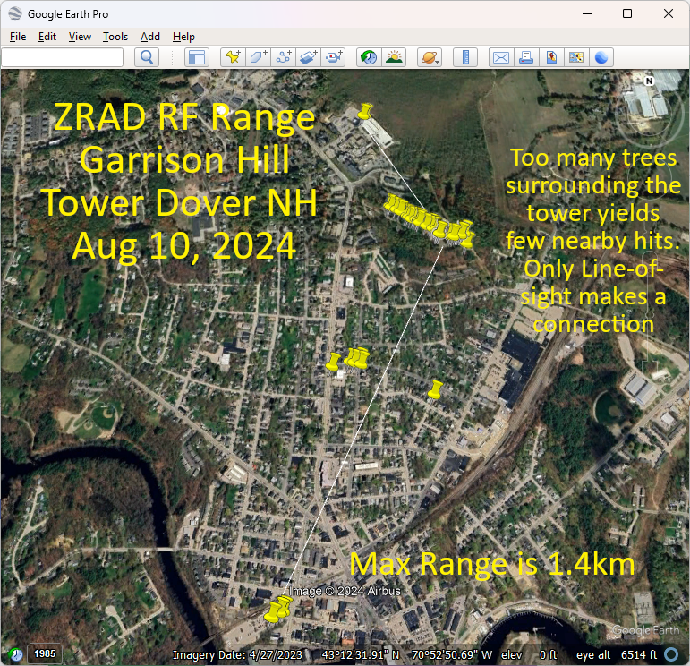Trial run at the Garrison Hill tower which has a commanding view of the city of Dover NH. The problem is the tower is surrounded with a thick forest which from the top of the tower you can just see over the tops of the trees. This means there are no connections made to the streets immediately below the tower thru all the trees. The few line-of-sight locations in the city will connect at over 1.4km but there are few of these at ground level. Lots of 3 story buildings and more trees block the LoS.

Download Google Earth Pro which can import the .csv file and display it on a map and take measurements. Note that the online version of Google Earth does NOT have the feature to import a .csv file. This does not appear to import the altitude, just 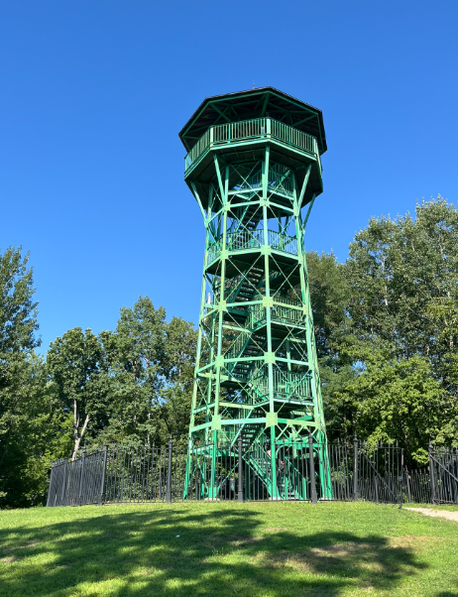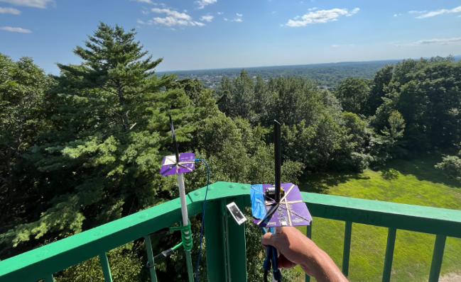Lat/Lon. Tried a few CSV to KML conversion utilities but GE still doesn’t seem to how the altitude.

Still looking for a mapping solution that will produce a 3D model for skydiving or rocketry that shows the altitude.

Raw data:

Time, Latitude, Longitude, Altitude, TxPower, RSSI, Sat Aug 10 2024 15:19:13 GMT-0400 (Eastern Daylight Time)

03:19:13 PM, 43.20914840698242, -70.8693618774414, 182.85, 0, 0

03:19:13 PM, 43.20912551879883, -70.86934661865234, 182.85, 0, 0

03:19:13 PM, 43.2091064453125, -70.86935424804688, 182.85, 0, 0

03:19:13 PM, 43.209556579589844, -70.8694076538086, 110.76, 0, 0

03:19:13 PM, 43.20950698852539, -70.86963653564453, 112.66, 0, 0

03:19:13 PM, 43.20948028564453, -70.86962127685547, 112.71, 0, 0

03:19:13 PM, 43.20952224731445, -70.86958312988281, 112.74, 0, 0

03:19:13 PM, 43.209510803222656, -70.86959075927734, 112.79, 0, 0

03:19:13 PM, 43.209510803222656, -70.86959075927734, 112.79, 0, 0

03:19:13 PM, 43.20949172973633, -70.86959075927734, 112.79, 0, 0

03:19:13 PM, 43.20949172973633, -70.86958312988281, 112.79, 0, 0

03:19:13 PM, 43.20948028564453, -70.86958312988281, 112.92, 0, 0

03:19:13 PM, 43.20948028564453, -70.86958312988281, 113.18, 0, 0

03:19:13 PM, 43.20948028564453, -70.86957550048828, 113.33, 0, 0

03:19:13 PM, 43.20948028564453, -70.86957550048828, 113.33, 0, 0

03:19:13 PM, 43.2094841003418, -70.86957550048828, 113.57, 0, 0

03:19:13 PM, 43.20949935913086, -70.86959075927734, 114.15, 0, 0

03:19:13 PM, 43.209503173828125, -70.86958312988281, 114.19, 0, 0

03:19:13 PM, 43.209495544433594, -70.86959075927734, 114.23, 0, 0

03:19:13 PM, 43.20949935913086, -70.86959075927734, 114.26, 0, 0

03:19:13 PM, 43.20949935913086, -70.86959075927734, 114.27, 0, 0

03:19:13 PM, 43.209495544433594, -70.86959838867188, 114.39, 0, 0

03:19:13 PM, 43.20949935913086, -70.86959838867188, 114.4, 0, 0

03:19:13 PM, 43.209495544433594, -70.86959838867188, 114.44, 0, 0

03:19:13 PM, 43.20949935913086, -70.86959075927734, 114.23, 0, 0

03:19:13 PM, 43.209503173828125, -70.8696060180664, 114.28, 0, 0

03:19:13 PM, 43.20951843261719, -70.86962127685547, 114.25, 0, 0

03:19:13 PM, 43.20949172973633, -70.86962890625, 114.39, 0, 0

03:19:13 PM, 43.20949172973633, -70.86962890625, 114.46, 0, 0

03:19:13 PM, 43.20948791503906, -70.86962890625, 114.72, 0, 0

03:19:13 PM, 43.20948791503906, -70.86962890625, 114.76, 0, 0

03:19:13 PM, 43.20949172973633, -70.86962890625, 114.76, 0, 0

03:19:13 PM, 43.209495544433594, -70.86962890625, 114.22, 0, 0

03:19:13 PM, 43.209495544433594, -70.86962127685547, 114.05, 0, 0

03:19:13 PM, 43.209495544433594, -70.86961364746094, 114.02, 0, 0

03:19:13 PM, 43.209495544433594, -70.8696060180664, 114.01, 0, 0

03:19:13 PM, 43.209495544433594, -70.8696060180664, 114.28, 0, 0

03:19:13 PM, 43.209495544433594, -70.8696060180664, 114.37, 0, 0

03:19:13 PM, 43.20949935913086, -70.86961364746094, 114.45, 0, 0

03:19:13 PM, 43.20950698852539, -70.86961364746094, 114.48, 0, 0

03:19:13 PM, 43.209495544433594, -70.86962890625, 113.76, 0, 0

03:19:13 PM, 43.209495544433594, -70.86963653564453, 113.7, 0, 0

03:19:13 PM, 43.20950698852539, -70.86963653564453, 113.49, 0, 0

03:19:13 PM, 43.209495544433594, -70.86964416503906, 112.86, 0, 0

03:19:13 PM, 43.209449768066406, -70.86972045898438, 113.86, 0, 0

03:19:13 PM, 43.20943069458008, -70.86981201171875, 116.74, 0, 0

03:19:13 PM, 43.20942306518555, -70.86993408203125, 118.76, 0, 0

03:19:13 PM, 43.209434509277344, -70.87007141113281, 120.62, 0, 0

03:19:13 PM, 43.20954895019531, -70.87053680419922, 118.04, 0, 0

03:19:13 PM, 43.20954895019531, -70.87054443359375, 117.98, 0, 0

03:19:13 PM, 43.20954895019531, -70.87054443359375, 118.11, 0, 0

03:19:13 PM, 43.20954513549805, -70.87055206298828, 117.93, 0, 0

03:19:13 PM, 43.20953369140625, -70.87055969238281, 117.61, 0, 0

03:19:13 PM, 43.209537506103516, -70.87055206298828, 117.55, 0, 0

03:19:13 PM, 43.20953369140625, -70.87055206298828, 117.59, 0, 0

03:19:13 PM, 43.20953369140625, -70.87055206298828, 117.62, 0, 0

03:19:13 PM, 43.20953369140625, -70.87055206298828, 117.63, 0, 0

03:19:13 PM, 43.20953369140625, -70.87055206298828, 116.77, 0, 0

03:19:13 PM, 43.209529876708984, -70.87055969238281, 116.38, 0, 0

03:19:13 PM, 43.20952606201172, -70.87056732177734, 115.39, 0, 0

03:19:13 PM, 43.20953369140625, -70.87055969238281, 115.86, 0, 0

03:19:13 PM, 43.209529876708984, -70.87055969238281, 115.28, 0, 0

03:19:13 PM, 43.209529876708984, -70.87055969238281, 115.12, 0, 0

03:19:13 PM, 43.209529876708984, -70.87055969238281, 115.1, 0, 0

03:19:13 PM, 43.209529876708984, -70.87055206298828, 115.16, 0, 0

03:19:13 PM, 43.209529876708984, -70.87055206298828, 115.16, 0, 0

03:19:13 PM, 43.209529876708984, -70.87055206298828, 114.67, 0, 0

03:19:13 PM, 43.209529876708984, -70.87055206298828, 114.61, 0, 0

03:19:13 PM, 43.209529876708984, -70.87054443359375, 114.56, 0, 0

03:19:13 PM, 43.209529876708984, -70.87054443359375, 114.37, 0, 0

03:19:13 PM, 43.20952606201172, -70.87054443359375, 112.99, 0, 0

03:19:13 PM, 43.20952606201172, -70.87054443359375, 113.14, 0, 0

03:19:13 PM, 43.209537506103516, -70.87054443359375, 113.21, 0, 0

03:19:13 PM, 43.20954513549805, -70.87054443359375, 113.26, 0, 0

03:19:13 PM, 43.20954513549805, -70.87055206298828, 113.24, 0, 0

03:19:13 PM, 43.2096061706543, -70.87062072753906, 113.13, 0, 0

03:19:13 PM, 43.209716796875, -70.870849609375, 109.28, 0, 0

03:19:13 PM, 43.209815979003906, -70.87113952636719, 102.61, 0, 0

03:19:13 PM, 43.20994186401367, -70.87145233154297, 96.4, 0, 0

03:19:13 PM, 43.204952239990234, -70.87549591064453, 39.67, 0, 0

03:19:13 PM, 43.197731018066406, -70.87783813476562, 28.76, 0, 0

03:19:13 PM, 43.19785690307617, -70.87754821777344, 29.44, 0, 0

03:19:13 PM, 43.19789505004883, -70.8774185180664, 29.73, 0, 0

03:19:13 PM, 43.204017639160156, -70.87120819091797, 38.08, 0, 0

03:19:13 PM, 43.20500564575195, -70.87425994873047, 52.11, 0, 0

03:19:13 PM, 43.20512008666992, -70.87433624267578, 52.22, 0, 0

03:19:13 PM, 43.20505905151367, -70.87454986572266, 52.2, 0, 0

03:19:13 PM, 43.20509338378906, -70.87472534179688, 51.47, 0, 0

03:19:13 PM, 43.214290618896484, -70.87380981445312, 71.92, 0, 0

03:19:13 PM, 43.21426010131836, -70.87390899658203, 72, 0, 0

03:19:13 PM, 43.214263916015625, -70.87390899658203, 71.91, 0, 0

03:19:13 PM, 43.214263916015625, -70.8739013671875, 71.94, 0, 0

03:19:13 PM, 43.2105827331543, -70.87279510498047, 80.26, 0, 0

03:19:13 PM, 43.21054458618164, -70.87272644042969, 81.1, 0, 0

03:19:13 PM, 43.21044921875, -70.87248992919922, 85.54, 0, 0

03:19:13 PM, 43.210365295410156, -70.87230682373047, 89.83, 0, 0

03:19:13 PM, 43.2101936340332, -70.87200164794922, 100.19, 0, 0

03:19:13 PM, 43.21015930175781, -70.87191772460938, 102.55, 0, 0

03:19:13 PM, 43.210086822509766, -70.87181854248047, 103.75, 0, 0

03:19:13 PM, 43.210086822509766, -70.87167358398438, 105.19, 0, 0

03:19:13 PM, 43.21006774902344, -70.87158203125, 105.62, 0, 0

03:19:13 PM, 43.210025787353516, -70.8714828491211, 106.06, 0, 0

03:19:13 PM, 43.210018157958984, -70.87147521972656, 106.04, 0, 0

03:19:13 PM, 43.20982360839844, -70.87091064453125, 103.57, 0, 0

03:19:13 PM, 43.20981216430664, -70.87089538574219, 103.56, 0, 0

03:19:13 PM, 43.209693908691406, -70.87068176269531, 104.28, 0, 0

03:19:13 PM, 43.2095947265625, -70.87054443359375, 103.38, 0, 0

03:19:13 PM, 43.2095947265625, -70.87053680419922, 103.17, 0, 0

03:19:13 PM, 43.2095947265625, -70.87052917480469, 103.28, 0, 0

03:19:13 PM, 43.209590911865234, -70.87052917480469, 103.39, 0, 0

## 2024-08-09 – Call With Sam & Mark

Sam showed the script for the marketing video. Data is totally secondary but the real data is important to Mark and I. The production team is arriving Monday! Thursday Boston, Friday is NH.

## 2024-08-08 – Initial discussions with Mark Umina

Introduced Sam Ponedal who is Silabs marketing